Implement programs for estimating & eliminating trend in time series data – aggregation, smoothing.
EX:No.4 DATE:1/02/25

AIM:
To Implement programs for estimating & eliminating trend in time series data – aggregation, smoothing..

OBJECTIVE:
To estimate and remove trends in time-series air pollution data using aggregation and smoothing techniques.

BACKGROUND:
- Time series data often has trends that affect analysis.
- Aggregation (e.g., monthly/yearly averaging) helps identify patterns.
- Smoothing (e.g., moving average, exponential smoothing) removes fluctuations.
- Trend elimination improves forecasting and stationarity.

SCOPE OF THE PROGRAM:
- Load and clean air passengers data
- Apply aggregation (monthly/yearly averages) to estimate trends.
- Use moving average smoothing to reduce noise.
- Apply exponential smoothing to highlight trends

CODE:

# Step 1: Import necessary libraries
import pandas as pd
import matplotlib.pyplot as plt

# Step 2: Load the dataset
df = pd.read_csv("microsoft.csv") # Use correct path if needed

# Step 3: Convert 'Date' column to datetime format
df['Date'] = pd.to_datetime(df['Date'], errors='coerce')

# Step 4: Set 'Date' as index
df.set_index('Date', inplace=True)

# Step 5: Aggregation - Monthly & Yearly Average of Close Price
df_monthly = df['Close'].resample('M').mean()
df_yearly = df['Close'].resample('Y').mean()

# Step 6: Moving Average Smoothing (Rolling Mean)
df['Moving_Avg'] = df['Close'].rolling(window=12).mean()

# Step 7: Exponential Smoothing
df['Exp_Smooth'] = df['Close'].ewm(span=12, adjust=False).mean()

# Step 8: Plot Original vs Smoothed Data
plt.figure(figsize=(12, 6))
plt.plot(df['Close'], label="Original Close Price", alpha=0.5)
plt.plot(df['Moving_Avg'], label="Moving Avg (12 weeks)", color='red')
plt.plot(df['Exp_Smooth'], label="Exponential Smoothing", color='green')
plt.xlabel("Date")
plt.ylabel("Close Price")
plt.title("Microsoft Stock Trend Estimation & Elimination using Smoothing")
plt.legend()
plt.grid(True)
plt.tight_layout()
plt.show()

OUTPUT:

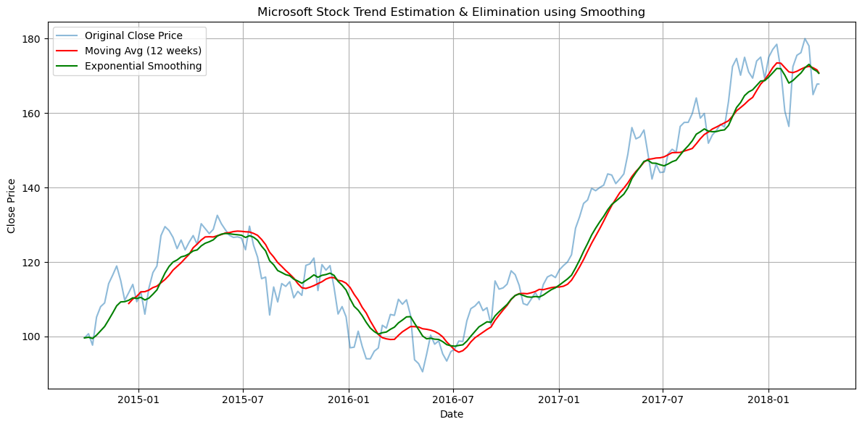

RESULT:
Thus, the program using the time series data implementation has been done successfully.

